**PL/SQL programming**

**Exercise 1: Control Structures**

--CREATE Customers Table

CREATE TABLE Customers (

CustomerID NUMBER PRIMARY KEY,

Name VARCHAR2(50),

Age NUMBER,

Balance NUMBER,

IsVIP VARCHAR2(5) DEFAULT 'FALSE'

);

--CREATE Loans Table

CREATE TABLE Loans (

LoanID NUMBER PRIMARY KEY,

CustomerID NUMBER,

InterestRate NUMBER(5,2),

DueDate DATE,

FOREIGN KEY (CustomerID) REFERENCES Customers(CustomerID)

);

--Insert customer details into Customers Table

INSERT INTO Customers VALUES (1, 'John Smith', 65, 15000, 'FALSE');

INSERT INTO Customers VALUES (2, 'Alice Brown', 45, 8000, 'FALSE');

INSERT INTO Customers VALUES (3, 'Michael Lee', 70, 12000, 'FALSE');

INSERT INTO Customers VALUES (4, 'Suresh Kumar', 62, 9500, 'FALSE');

INSERT INTO Customers VALUES (5, 'Meera Das', 68, 11000, 'FALSE');

INSERT INTO Customers VALUES (6, 'Rajiv Nair', 75, 30000, 'FALSE');

INSERT INTO Customers VALUES (7, 'Anita Sharma', 50, 10500, 'FALSE');

INSERT INTO Customers VALUES (8, 'Vikram Rao', 35, 4000, 'FALSE');

INSERT INTO Customers VALUES (9, 'Kiran Patil', 28, 16000, 'FALSE');

INSERT INTO Customers VALUES (10, 'Priya Sinha', 59, 10050, 'FALSE');

--Insert loan details into Loans Table

INSERT INTO Loans VALUES (101, 1, 7.5, TO_DATE('2025-07-10', 'YYYY-MM-DD'));

INSERT INTO Loans VALUES (102, 2, 6.0, TO_DATE('2025-08-15', 'YYYY-MM-DD'));

INSERT INTO Loans VALUES (103, 3, 8.0, TO_DATE('2025-06-30', 'YYYY-MM-DD'));

INSERT INTO Loans VALUES (104, 4, 7.0, TO_DATE('2025-07-01', 'YYYY-MM-DD'));

INSERT INTO Loans VALUES (105, 5, 6.8, TO_DATE('2025-07-25', 'YYYY-MM-DD'));

INSERT INTO Loans VALUES (106, 6, 7.9, TO_DATE('2025-07-15', 'YYYY-MM-DD'));

INSERT INTO Loans VALUES (107, 7, 6.5, TO_DATE('2025-08-20', 'YYYY-MM-DD'));

INSERT INTO Loans VALUES (108, 8, 6.3, TO_DATE('2025-07-10', 'YYYY-MM-DD'));

INSERT INTO Loans VALUES (109, 9, 6.0, TO_DATE('2025-06-29', 'YYYY-MM-DD'));

INSERT INTO Loans VALUES (110, 10, 6.9, TO_DATE('2025-07-30', 'YYYY-MM-DD'));

COMMIT;

--View Customers Table

SELECT * FROM Customers;

--View Loans Table

SELECT * FROM Loans;

--Scenario 1:

DECLARE

CURSOR cur_customers IS

SELECT CustomerID, InterestRate

FROM Loans

WHERE CustomerID IN (

SELECT CustomerID

FROM Customers

WHERE Age > 60

);

BEGIN

FOR rec IN cur_customers LOOP

UPDATE Loans

SET InterestRate = InterestRate - 1

WHERE CustomerID = rec.CustomerID;

END LOOP;

COMMIT;

END;

SELECT c.CustomerID, c.Name, c.Age, l.LoanID, l.InterestRate

FROM Customers c

JOIN Loans l ON c.CustomerID = l.CustomerID

WHERE c.Age > 60;

--Scenario 2:

BEGIN

FOR rec IN (

SELECT CustomerID

FROM Customers

WHERE Balance > 10000

) LOOP

UPDATE Customers

SET IsVIP = 'TRUE'

WHERE CustomerID = rec.CustomerID;

END LOOP;

COMMIT;

END;

SELECT CustomerID, Name, Balance, IsVIP

FROM Customers

WHERE IsVIP = 'TRUE';

--Scenario 3:

DECLARE

CURSOR cur_due_loans IS

SELECT l.CustomerID, l.DueDate, c.Name

FROM Loans l

JOIN Customers c ON l.CustomerID = c.CustomerID

WHERE l.DueDate <= SYSDATE + 30;

BEGIN

FOR rec IN cur_due_loans LOOP

DBMS_OUTPUT.PUT_LINE('Reminder: Loan for customer ' || rec.Name ||

' (ID: ' || rec.CustomerID || ') is due on ' || TO_CHAR(rec.DueDate, 'DD-MON-YYYY'));

END LOOP;

END;

SELECT l.CustomerID, c.Name, l.DueDate

FROM Loans l

JOIN Customers c ON l.CustomerID = c.CustomerID

WHERE l.DueDate <= SYSDATE + 30;

**OUTPUT:**

**Scenario 1:**

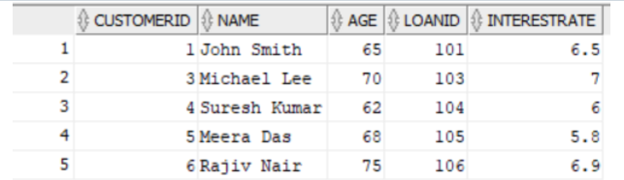

**Scenario 2:**

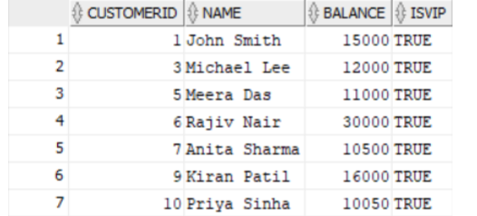

**Scenario 3:**

